**Lab 8**

**What Is String?**

A string is a data type used in programming, such as an integer and floating point unit, but is used to represent text rather than numbers. It is comprised of a set of characters that can also contain spaces and numbers. For example, the word "hamburger" and the phrase "I ate 3 hamburgers" are both strings. Even "12345" could be considered a string, if specified correctly. Typically, programmers must enclose strings in quotation marks for the data to recognized as a string and not a number or variable name.

* String is a collection of characters.
* String is a collection of ASCII characters.

**PHP chr() Function**

The chr() function returns a character from the specified ASCII value.

**Syntax**

chr(ascii)

**Example**

<?php

echo chr(65);

echo chr(122);

?>

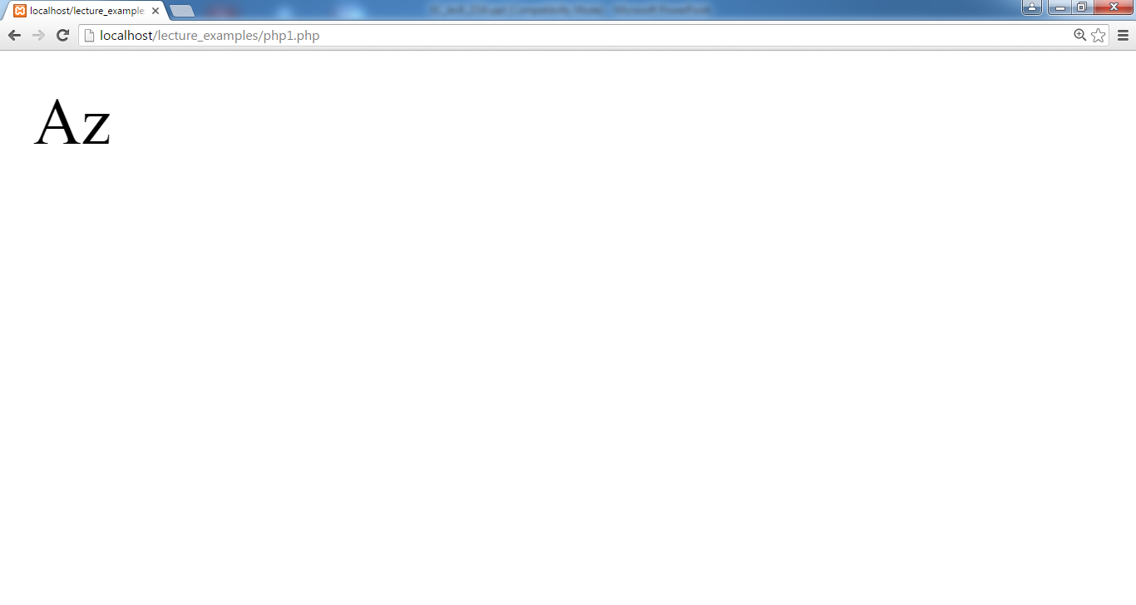

**PHP ord() Function**

The ord() function returns the ASCII value of the first character of a string.

**Syntax**

ord(string)

**Example**

<?php

echo ord(“h”).”<br />”;

echo ord(“hello”).”<br />”;

?>

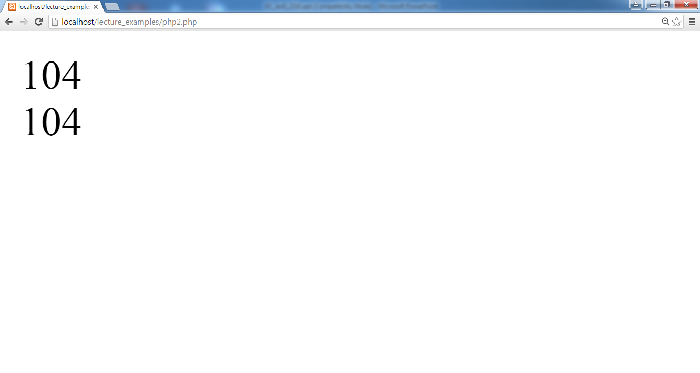

**PHP strlen() Function**

The strlen() function is used to return the length of a string.

**Syntax**

strlen(string)

**Example**

<?php

echo strlen("Hello world!");

?>

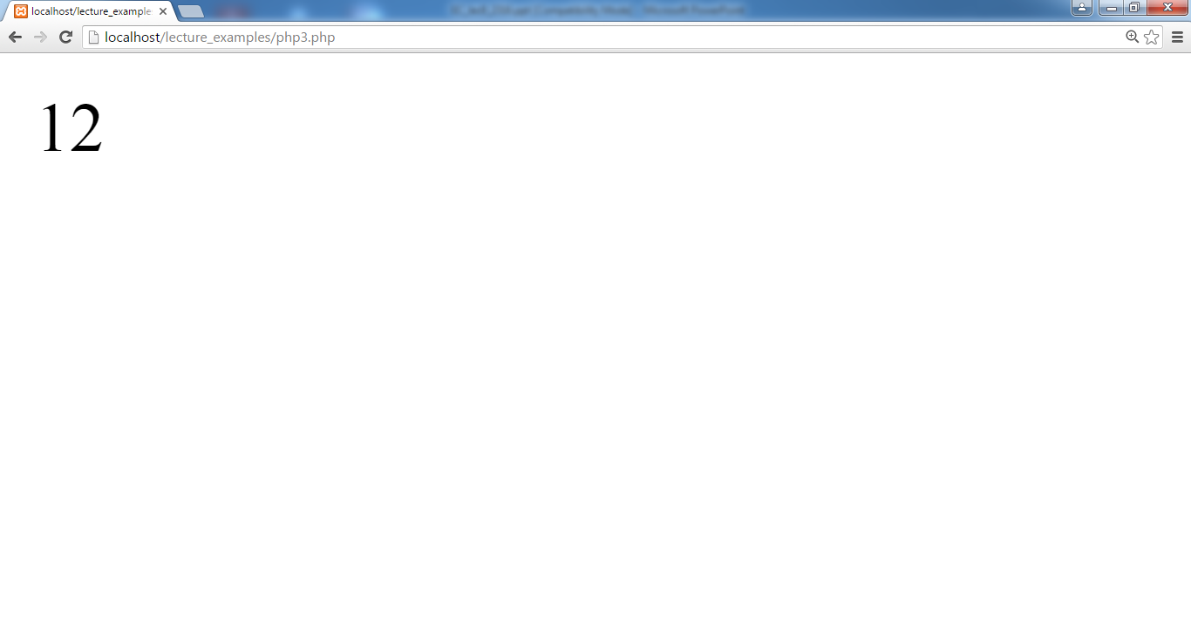

**PHP substr() Function**

The substr() function returns a part of a string.

**Syntax**

substr(string,start,length)

**Example**

<?php

echo substr("Hello world!",6);

echo substr("Hello world!",6,5);

?>

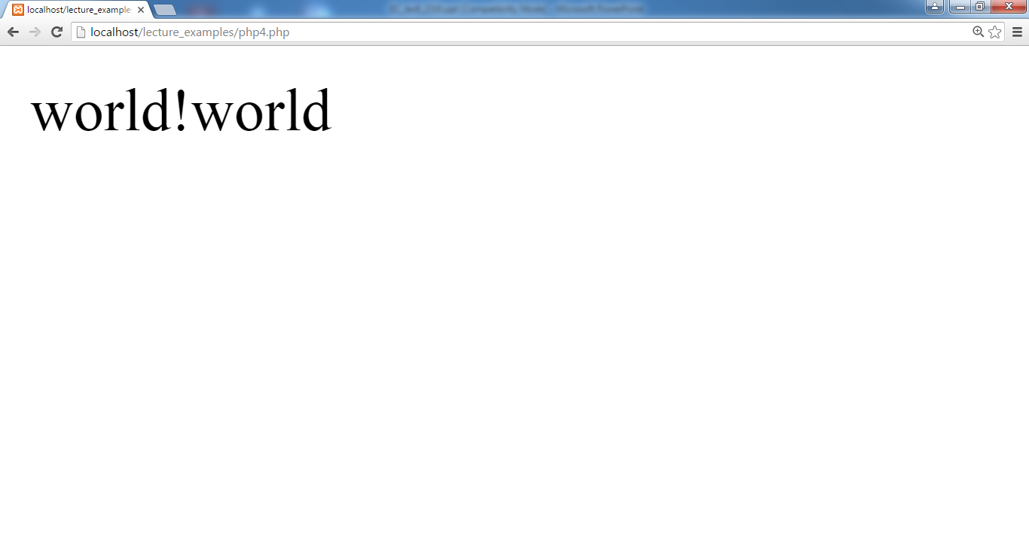

**PHP trim() Function**

The trim() function removes whitespaces from both sides of a string.

**Syntax**

trim(string)

**Example**

<?php

echo trim(“ Hello World ”);

?>

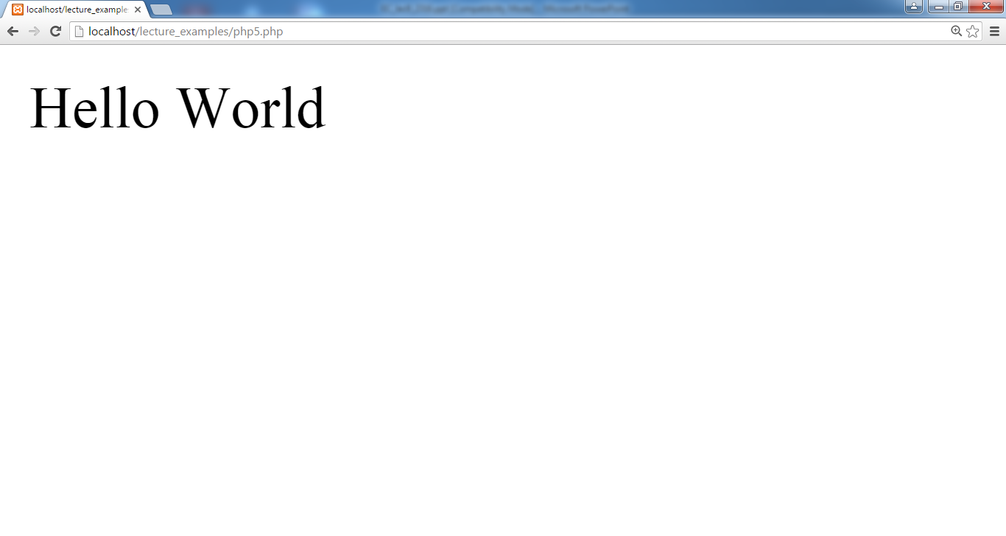

**PHP str_repeat() function**

str_repeat — Repeat a string

syntax:

string **str_repeat** ( string $input , int $multiplier )

***Note : multiplier*** : has to be greater than 0. If the ***multiplier*** is set to 0, the function will return an empty string.

**Example:**

<?php  
echo str_repeat("-=",10);  
?>

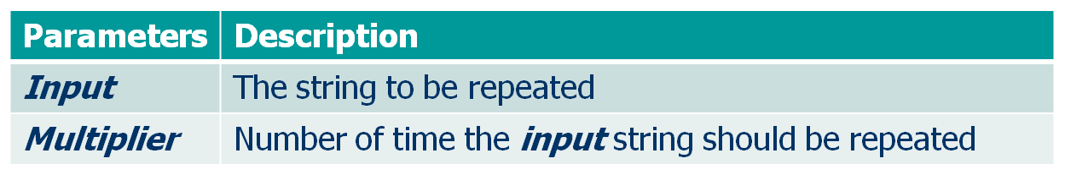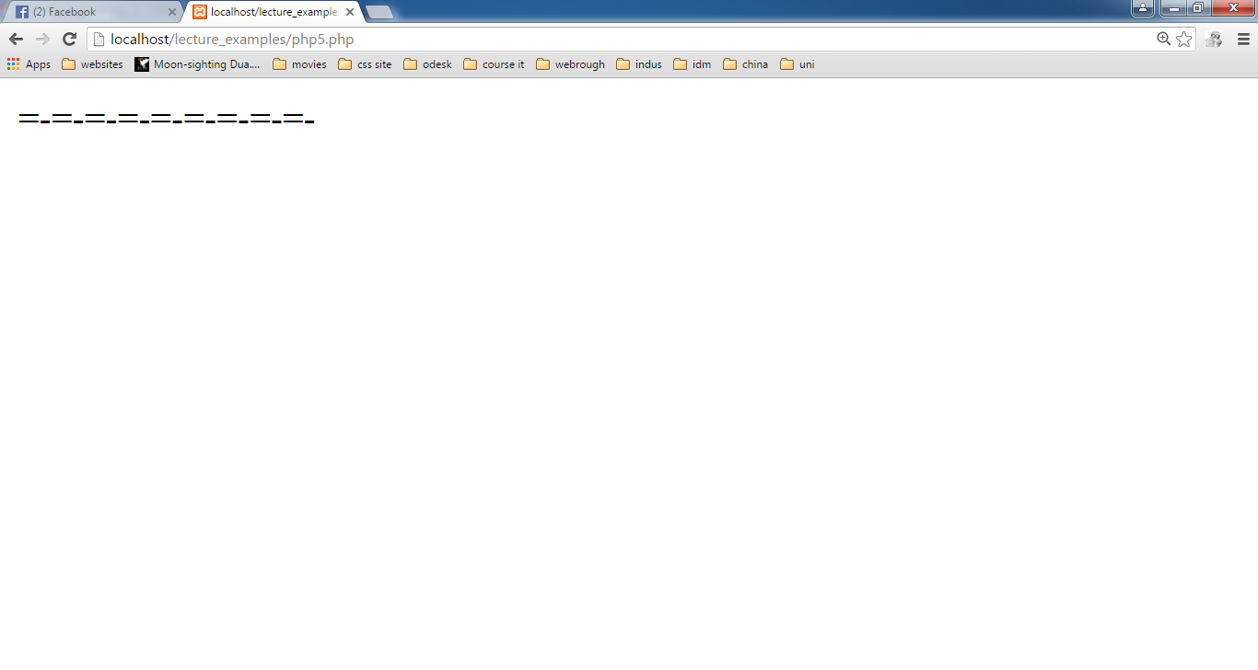

**Task#1:**

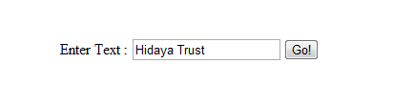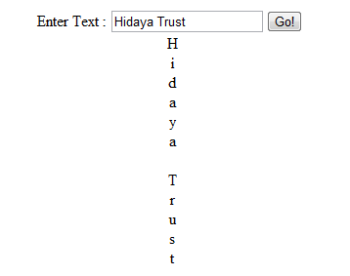

Enter String Text

Click

Output

**Task#2**

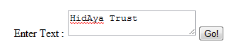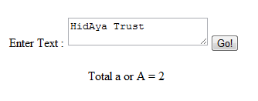

Enter String Text

Click

Output

**Task#3:**

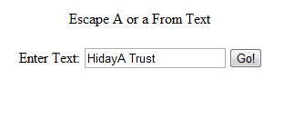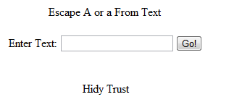

Enter String Text

Click

Output

**LAB# 8**

**PHP strpos() Function**

The strpos() function returns the position of the first occurrence of a string inside another string.

If the string is not found, this function returns FALSE.

**Syntax**

strpos(string,find,start)

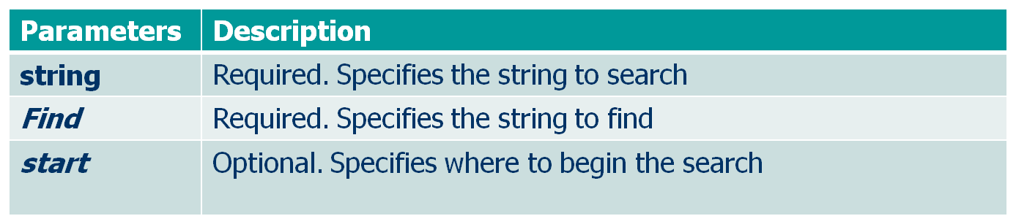

**PHP strpos() function continued……..**

Example 1:

<?php  
 echo strpos(“Hidaya Trust",“T");  
?>

Example 2:

<?php

$string ="Hello world";

echo strpos($string,"o world",1);

?>

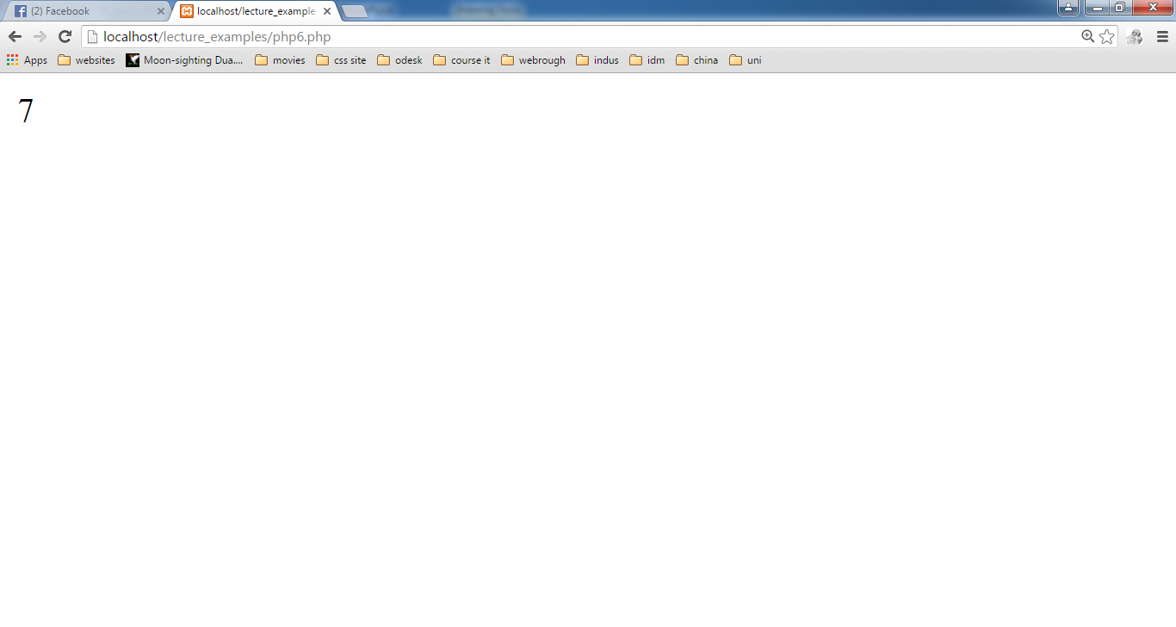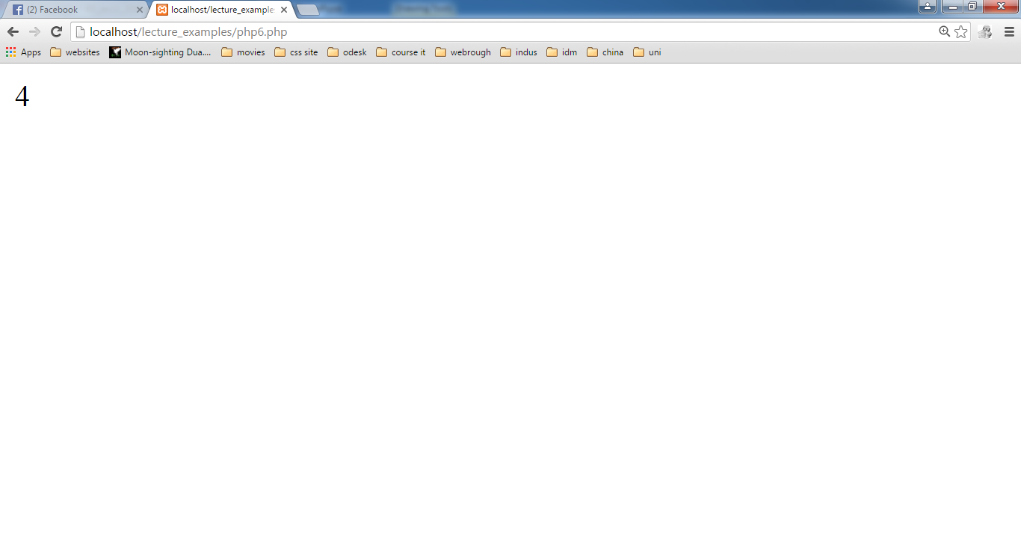

**PHP addslashes() Function**

addslashes — Quote string with slashes

The addslashes() function returns a string with backslashes in front of predefined characters.Returns a string with backslashes before characters that need to be quoted in database queries etc. These characters are single quote (***'***), double quote (***"***), backslash (***\***) and NUL (the **NULL** byte).

**The predefined characters  are:**

single quote (')

double quote (")

backslash (\)

NULL

**PHP addslashes() Function continued…………**

Syntax

string **addslashes** ( string $str )

Example

<?php

$str = "indus university student's work hard";

echo $str ."<br>";

echo addslashes($str);

?>



**PHP stripslashes() Function**

The stripslashes() function removes backslashes added by the addslashes() function.

Syntax

stripslashes(string)

Example

<?php

echo stripslashes("Who\'s Kai Jim?");

?>

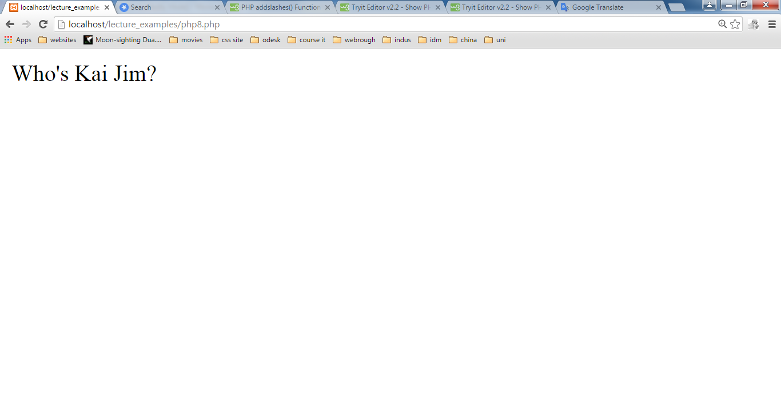

**PHP wordwrap() function**

The wordwrap() function wraps a string into new lines when it reaches a specific length.

This function returns the string broken into lines on success, or FALSE on failure.

**Syntax:**

wordwrap(string,width,break,cut)

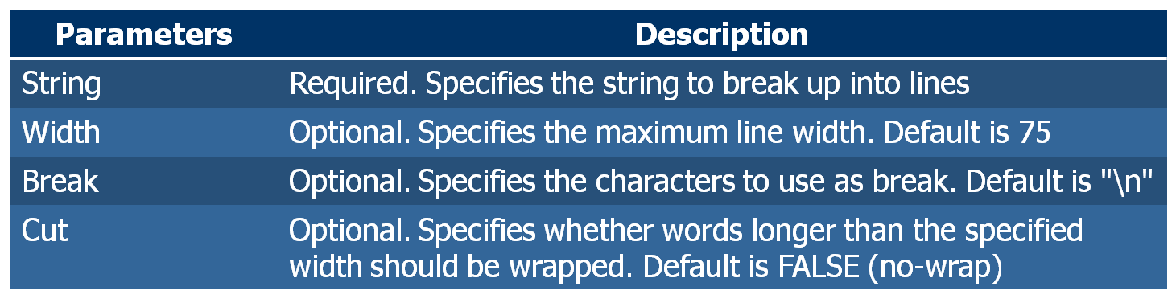

**PHP wordwrap() function continued**

**Example 1**

<?php

$str = "The wordwrap() function wraps a

string into new lines

when it reaches a specific length.";

echo wordwrap($str,25,"<br/>");

?>

**Exmaple 2**

<?php

$text="A very long wooooooord";

echo wordwrap($text,8,"<br>",true);

?>

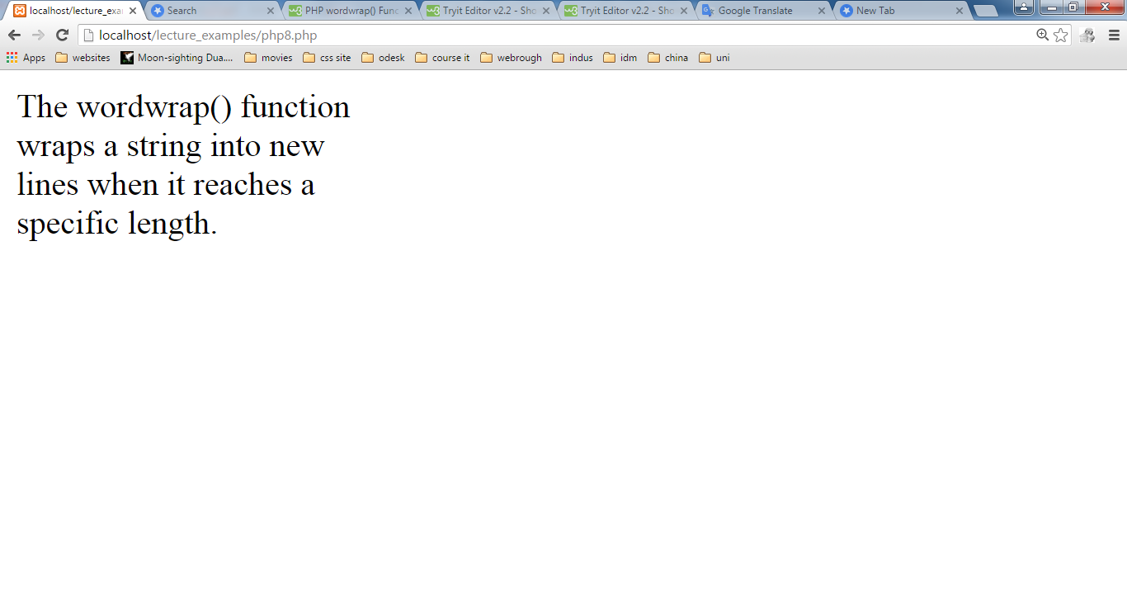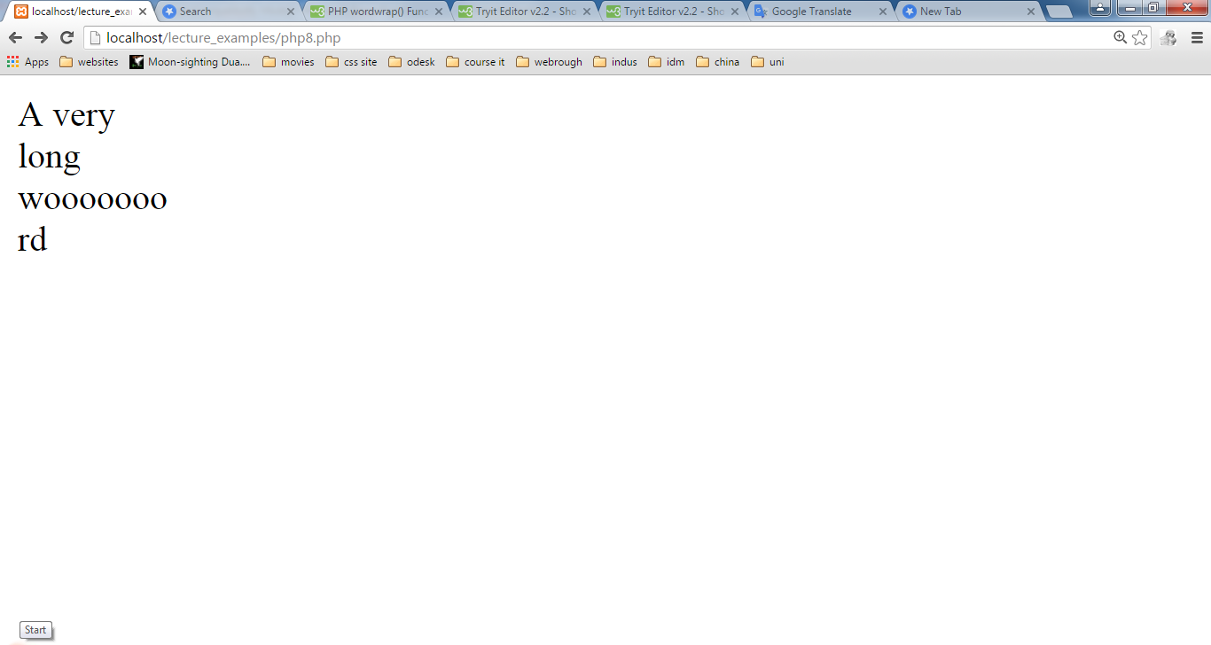

**PHP str_split() Function**

The str_split() function splits a string into an array.

Syntax

str_split(string,length)

**Note:**

**(1) -** If length is less than 1, the str_split() function will return FALSE.

**(2) -** If length is larger than the length of string, the entire string will be returned as the only element of the array.

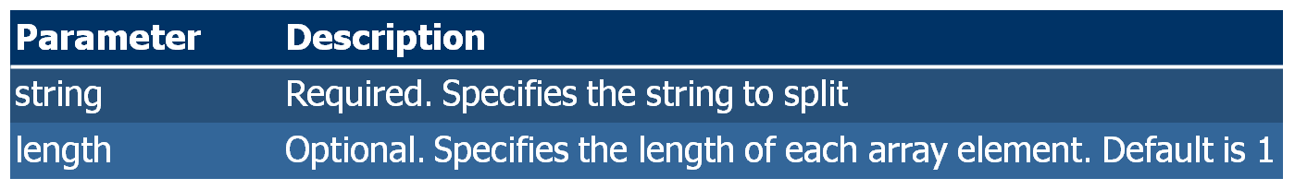

**PHP str_split() Function continued…….**

**Example 1**

<?php  
print_r(str_split("Hello"));  
?>

**Example 2**

<?php  
print_r(str_split("Hello",3));  
?>

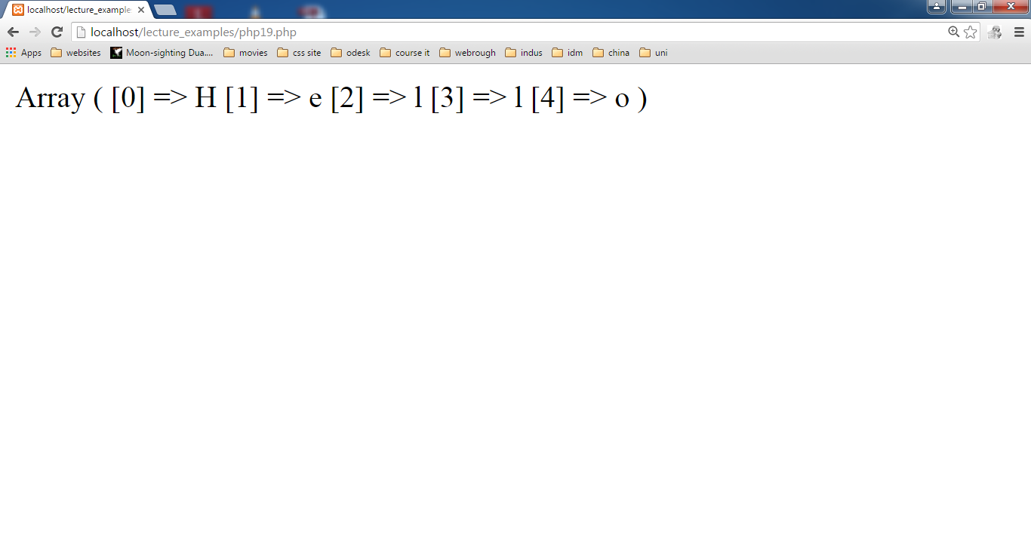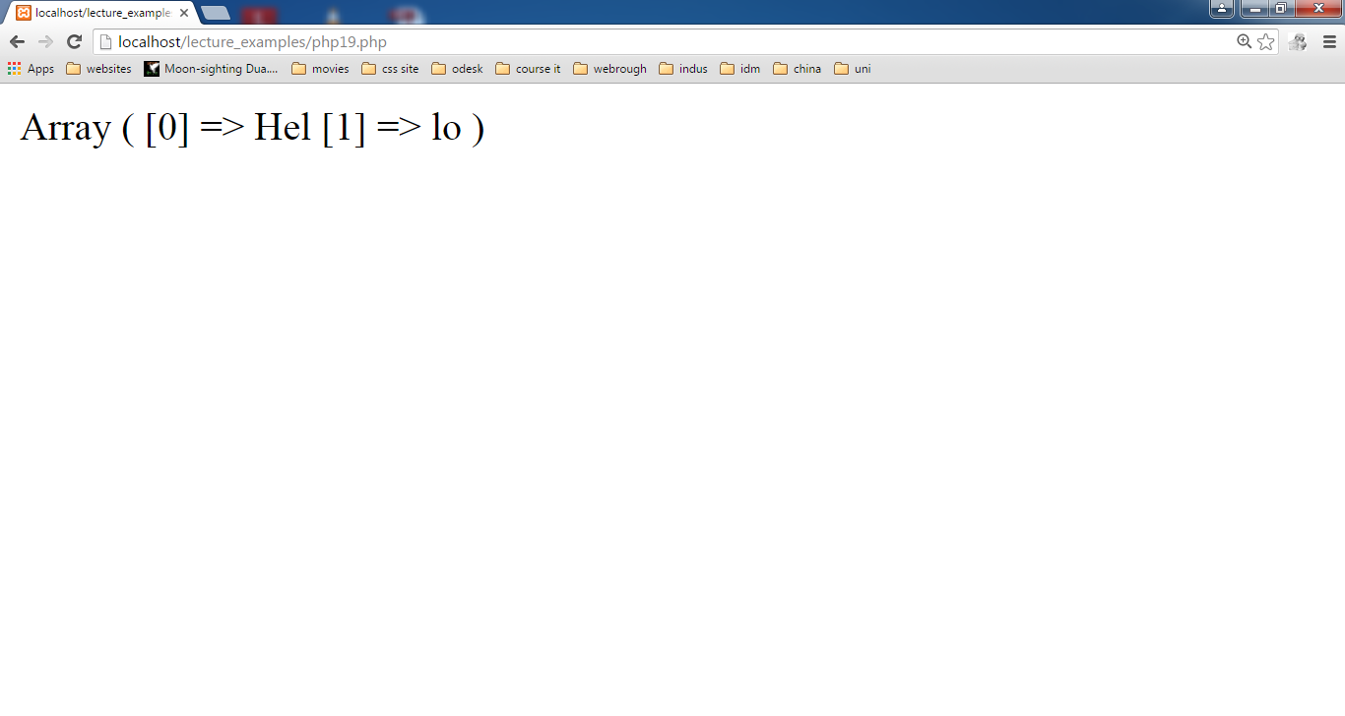

**Task#1**

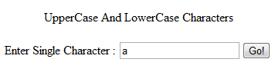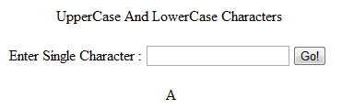

Character

Output

Click

**Task#2**

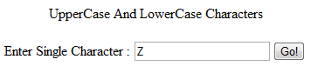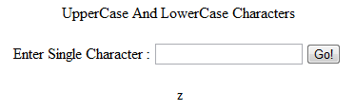

Character

Output

Click

**Task#3**

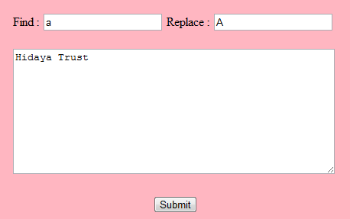

Enter some text here

Find character

Replace character

Click

Output

**LAB#9**

**PHP strrev() Function**

**This function reverse the string.**

**Syntax**

**strrev(string)**.

**Example:**

**<?php**

**$string="IndusUniversity";**

**echo $reversed=strrev($string);**

**?>**

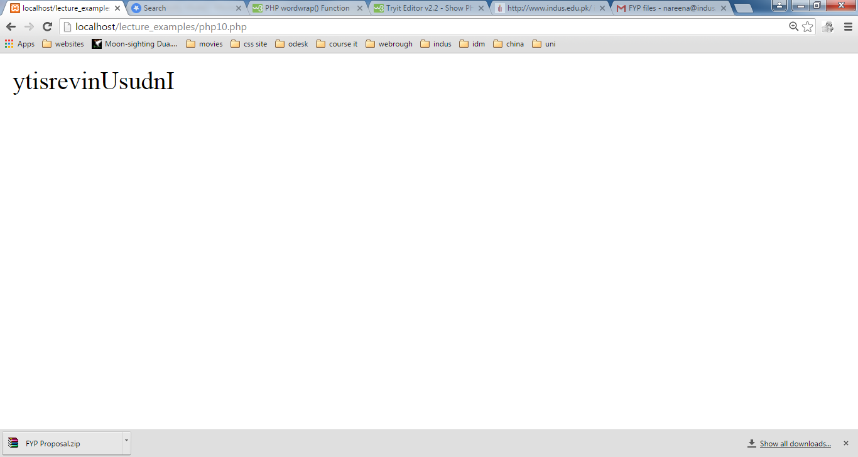

**PHP rand() Function**

**The rand() function generates a random integer.If this function is called without parameters, it returns a random integer between 0 and RAND_MAX.If you want a random number between 10 and 100 (inclusive), use rand (10,100).**

**Note: On some platforms (such as Windows) RAND_MAX is only 32767. So, if you require a range larger than 32767, you can specify min and max, or use the mt_rand() function instead.**

**The other random function, mt_rand() function generates a better random value than this function .**

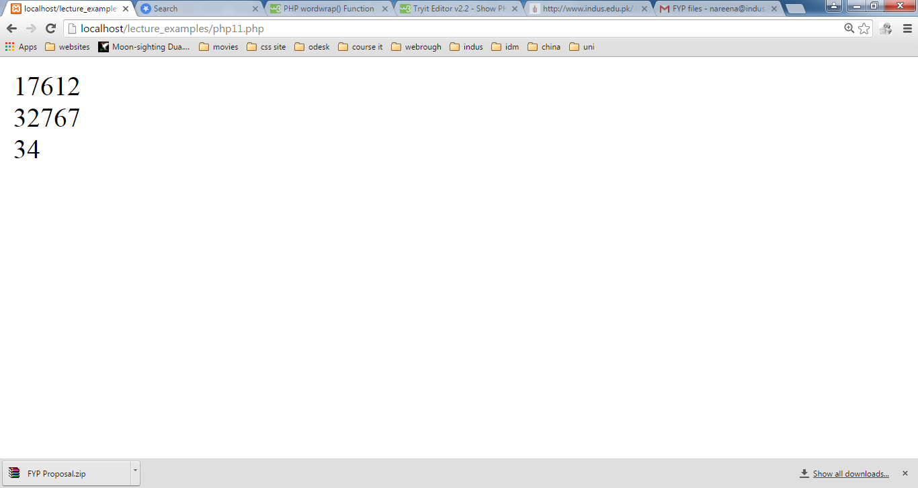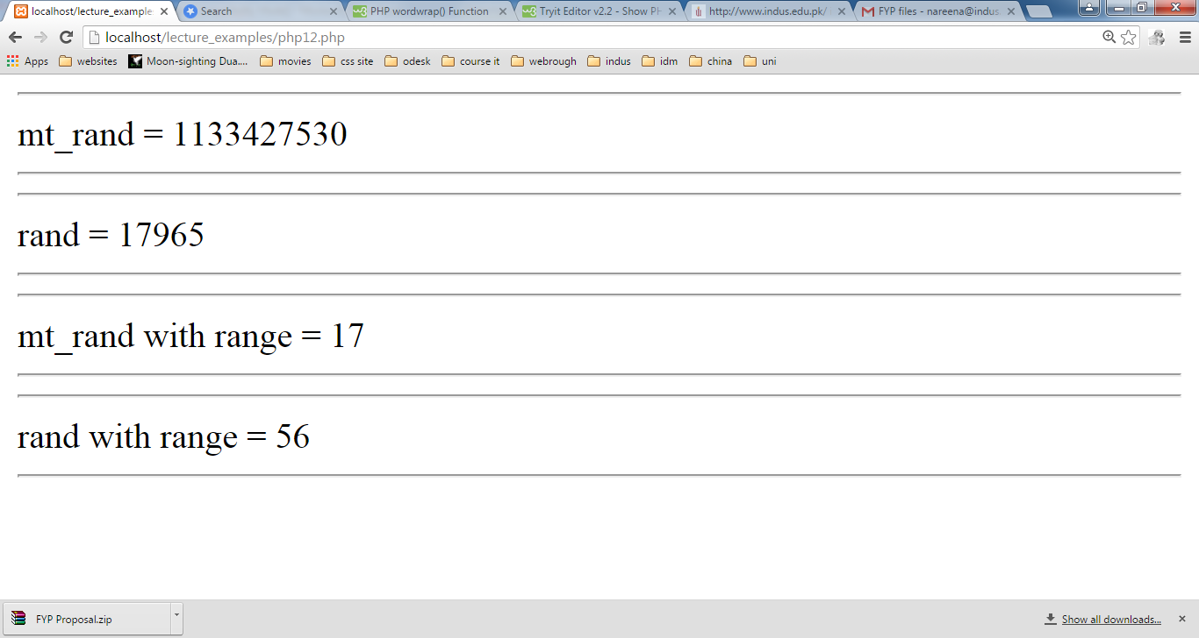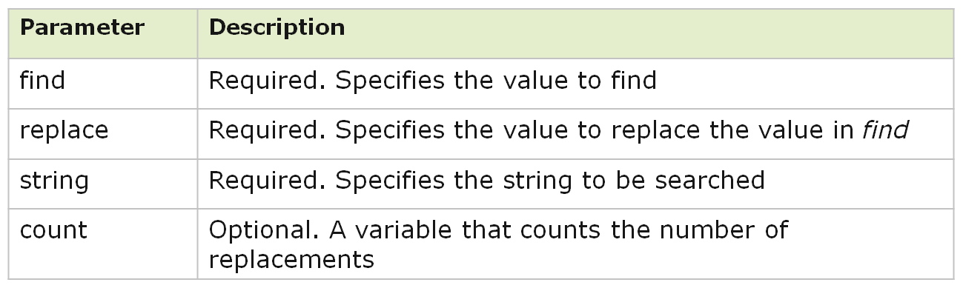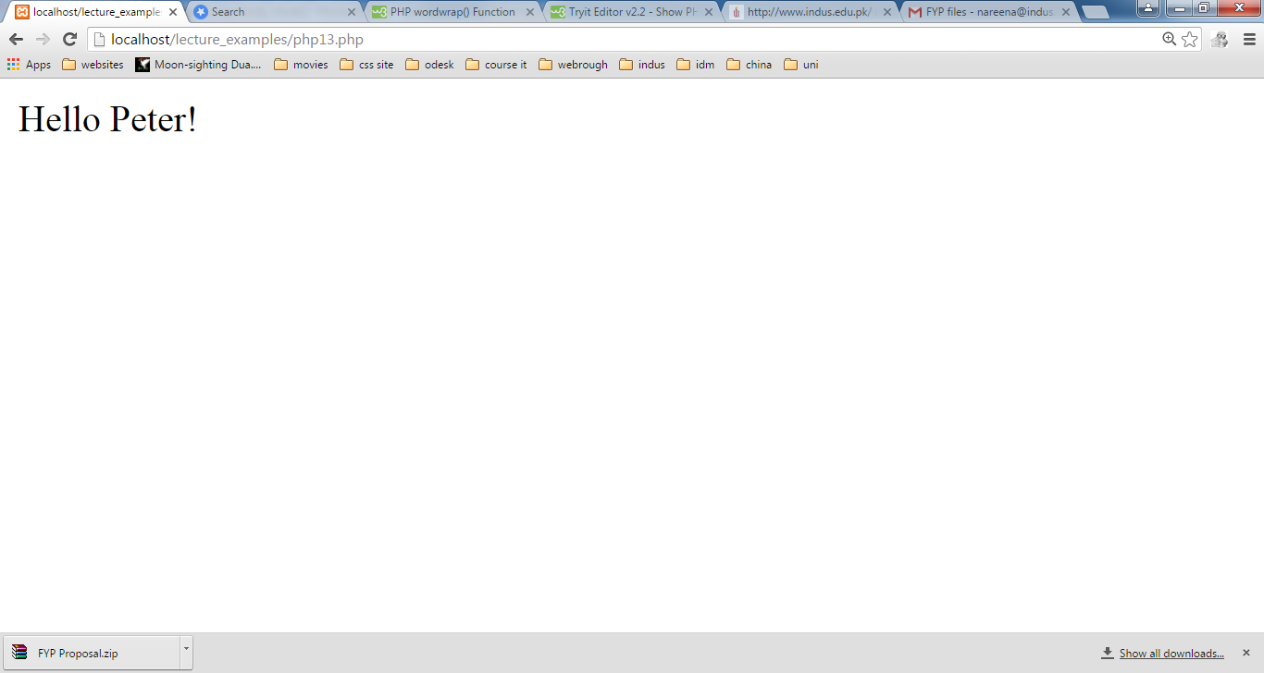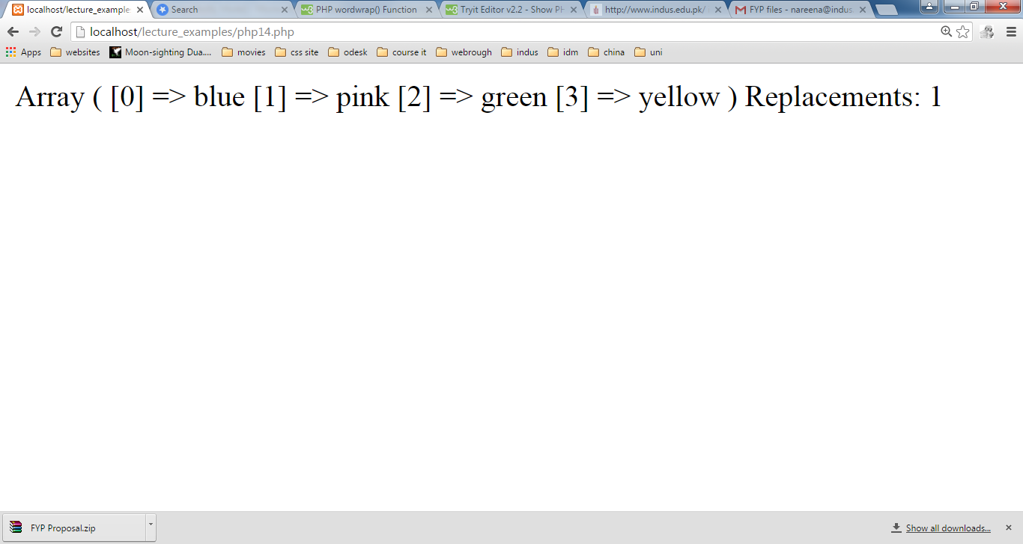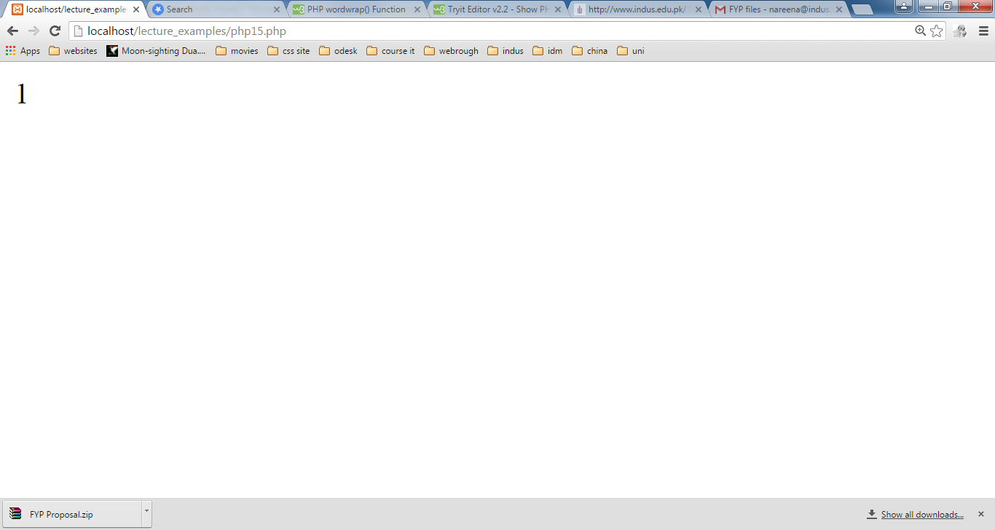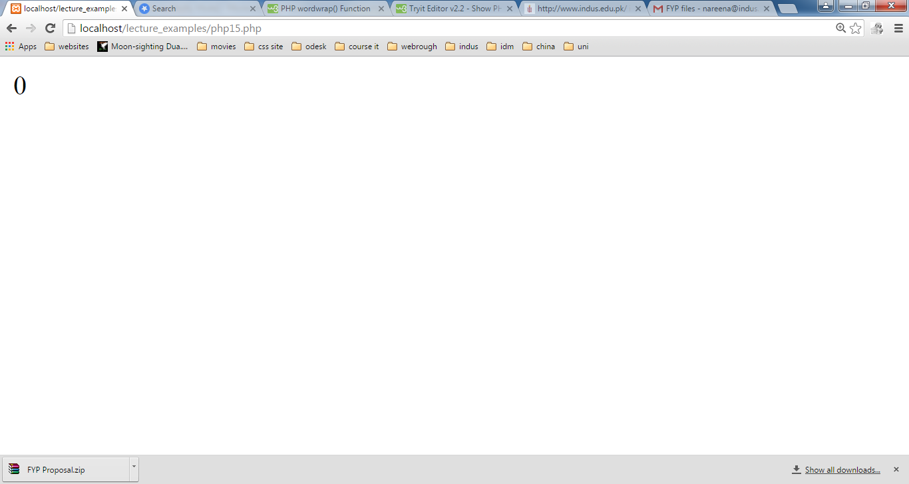

**Task1:**



Enter some text here

Find character

Replace character

Click

Output

**Task2:**

Click



Enter Text



Output

**LAB#10**

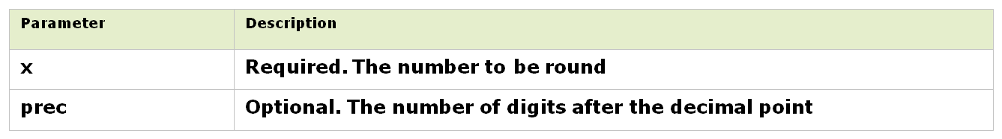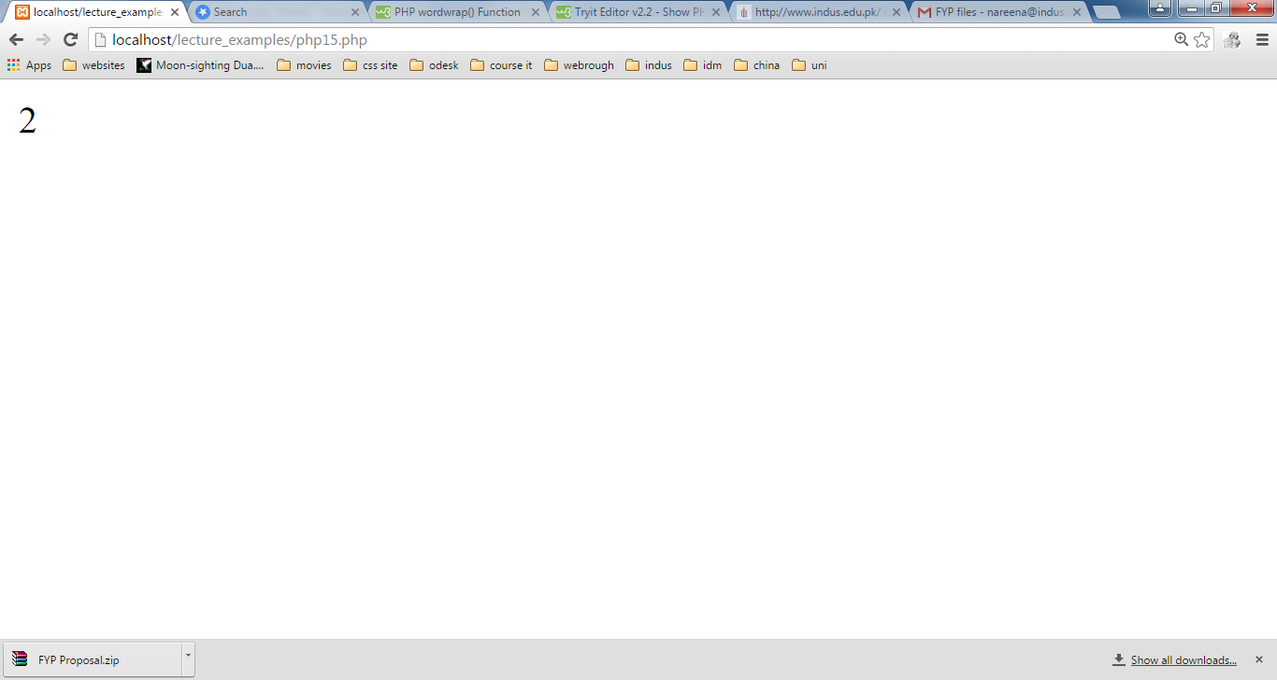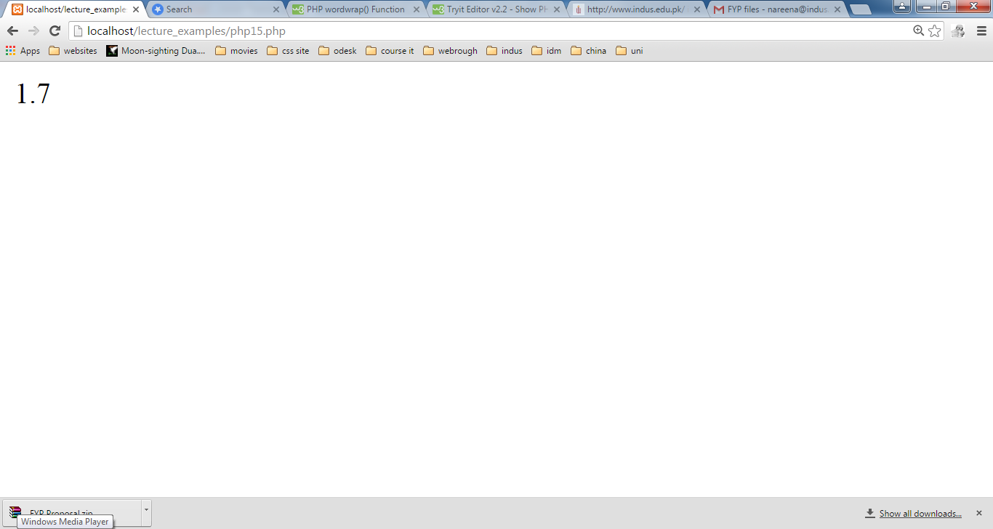

**PHP explode() Function**

The explode() function breaks a string into an array.

**Syntax**

explode(separator,string)

**Example**

<?php

$string = "Hello world. It's a beautiful day.";

print_r (explode(" ",$string));

?>

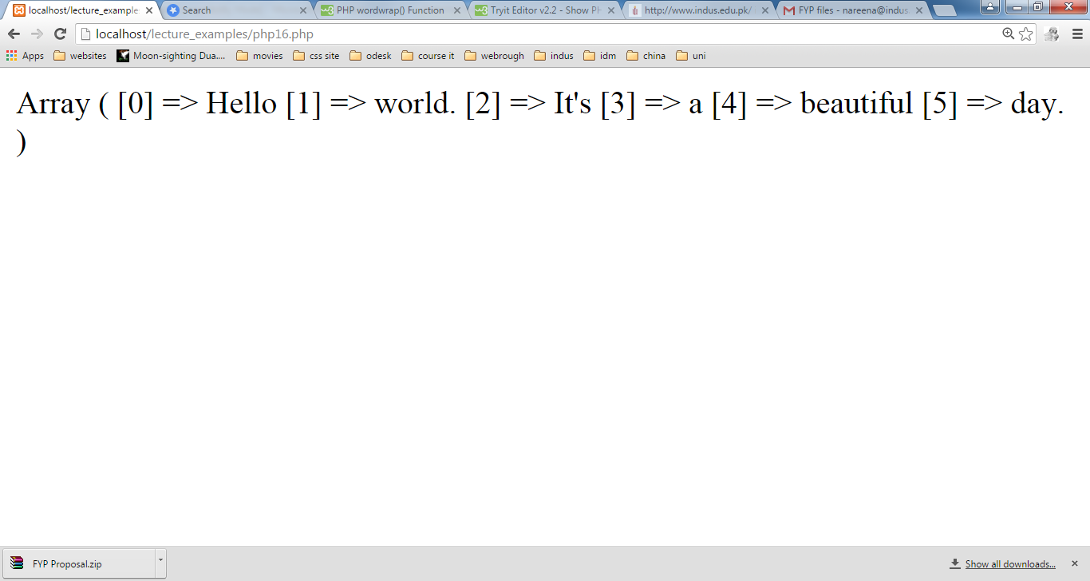

**PHP implode() Function**

The implode() function returns a string from the elements of an array.

**Syntax**

implode(separator,array)

**Example**

<?php

$array = array('Hello','World!','Beautiful','Day!');

//echo implode(“:",$array);

echo implode(“:",$array);

?>

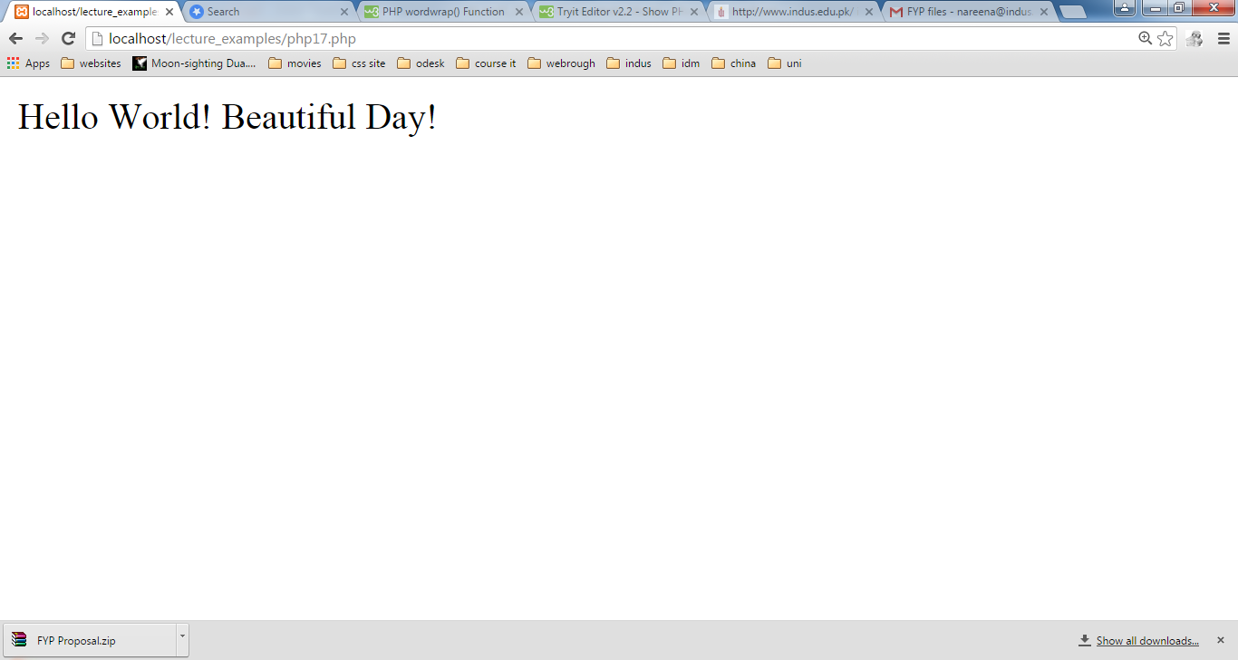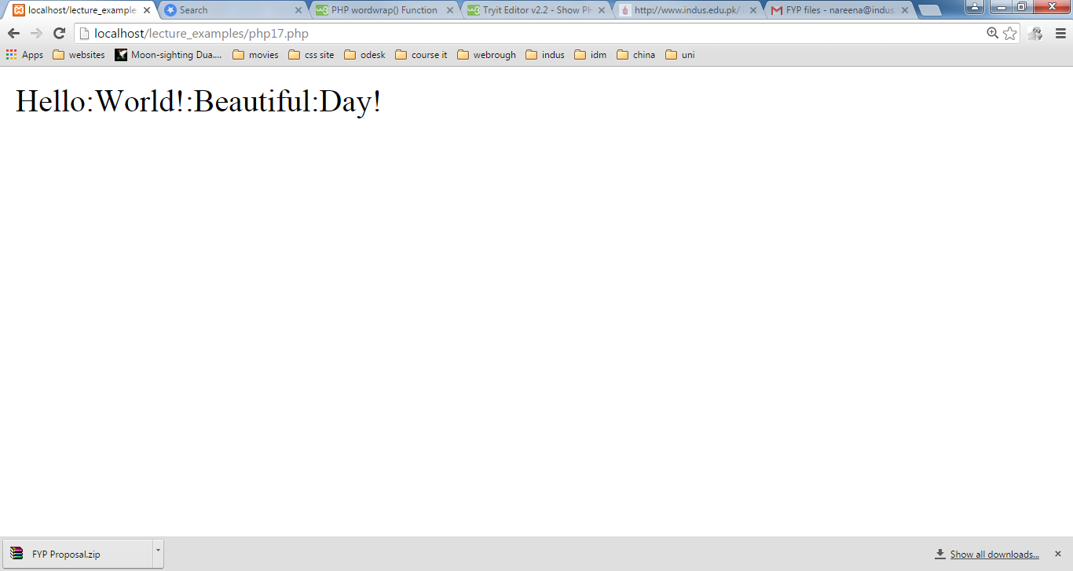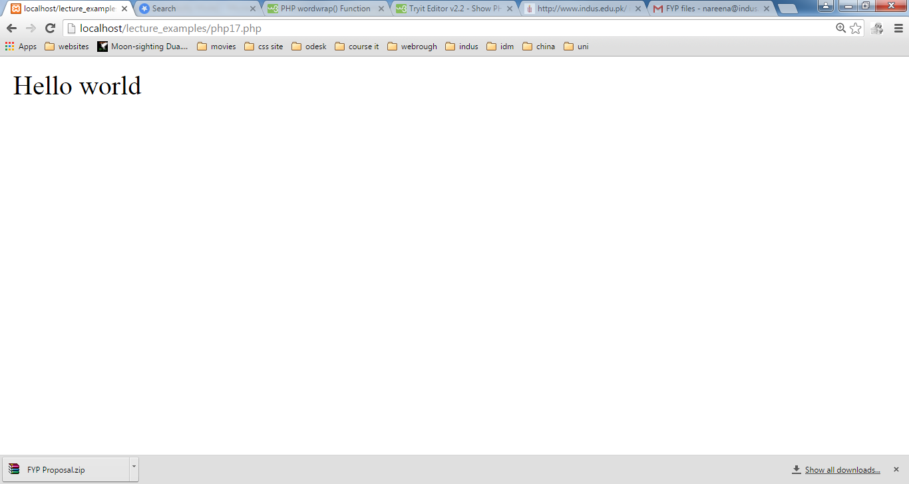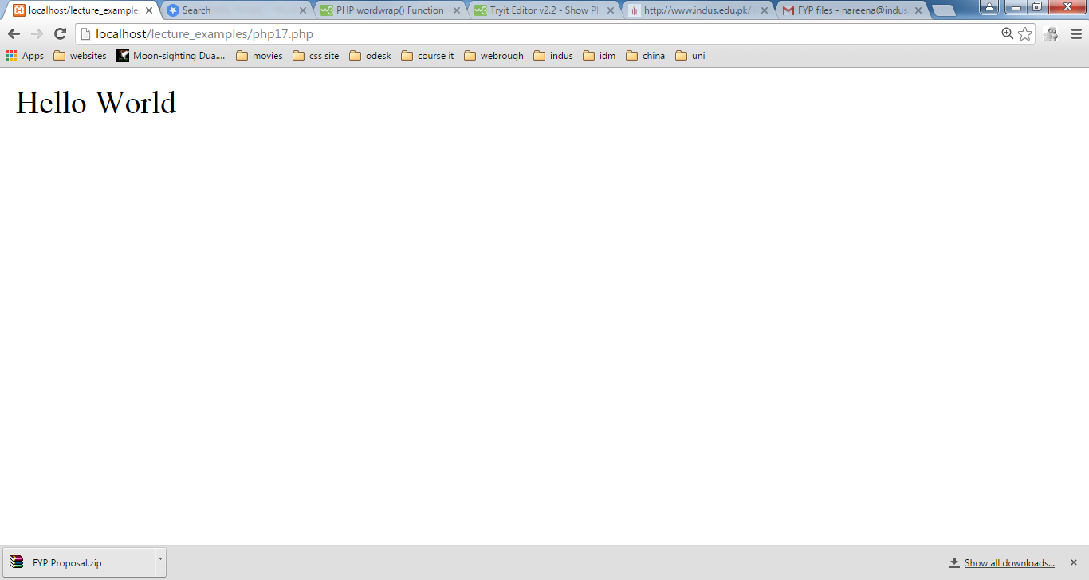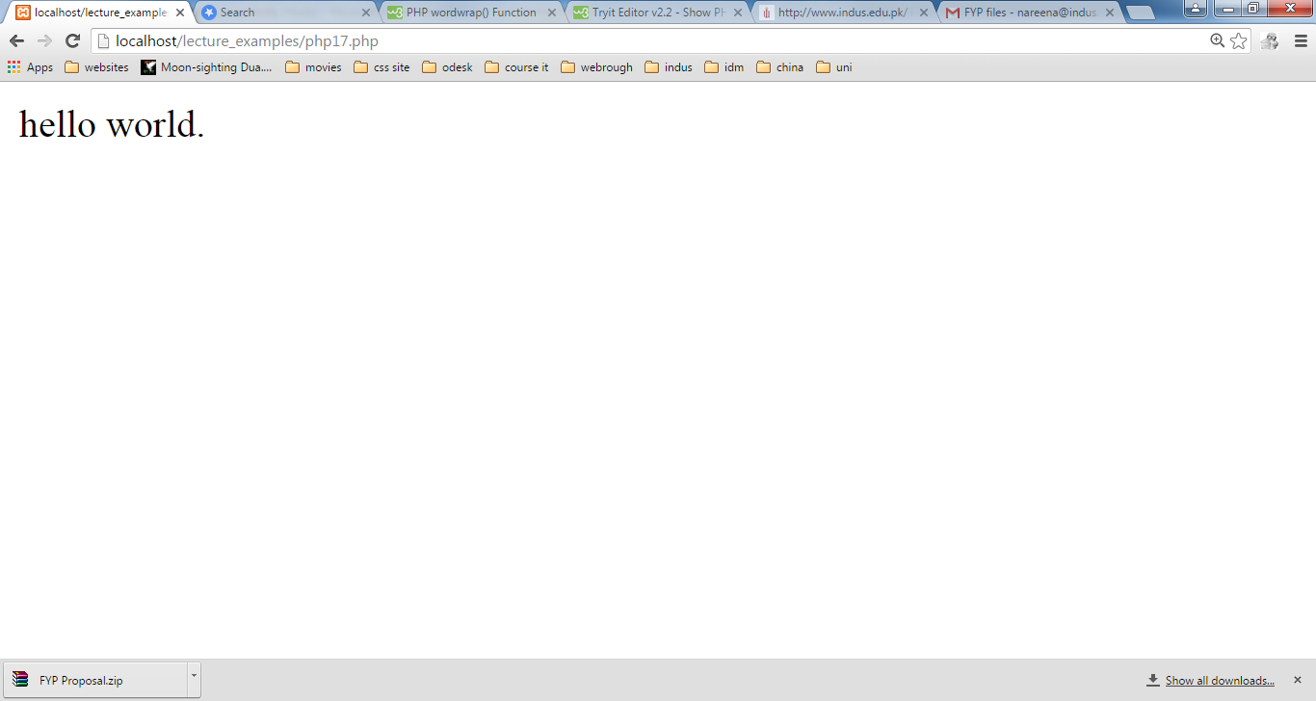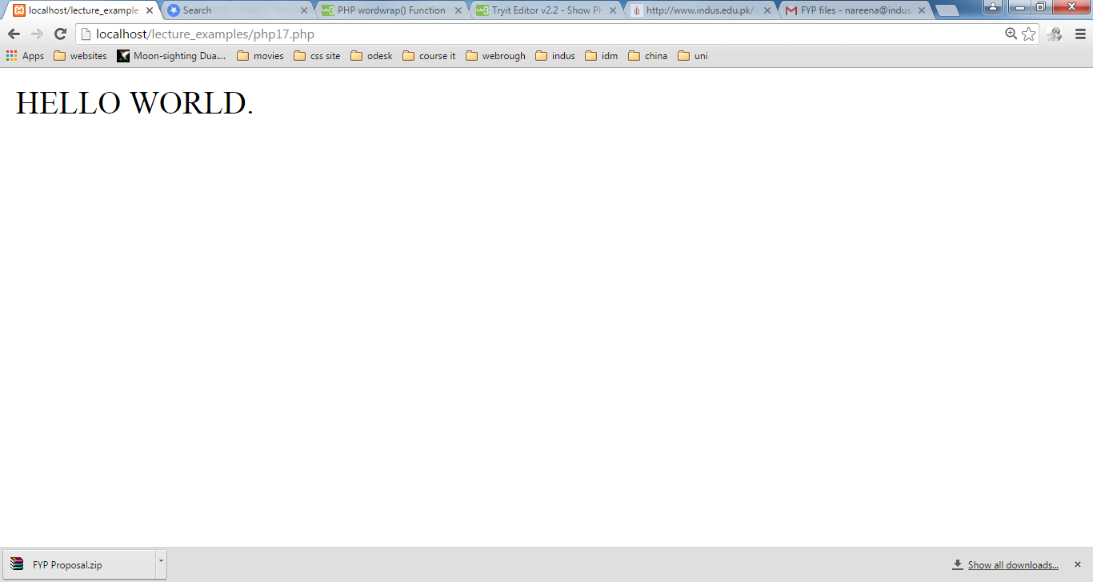

**PHP str_word_count() function**

It returns information about words used in a string

**Syntax :**

str_word_count(string)

**Example:**

<?php

$str = "Hi this is test";

echo str_word_count($str);

?>

**Output: 4**

**Task:**



Enter Text

Click



Output